**Implementing programs for visualizing time series data**

**AIM:** To implement a program for visualizing time series weather dataset.

**PROCEDURE:**

**Step 1:** Install and import necessary libraries.

import pandas as pd

import matplotlib.pyplot as plt

import seaborn as sns

from statsmodels.tsa.seasonal import seasonal_decompose

**Step 3:** Load and display the dataset.

data=pd.read_csv(r"/content/weather.csv")

data['Date.Full'] = pd.to_datetime(data['Date.Full'])

data.set_index('Date.Full', inplace=True)

**Step 3:** Visualize the dataset using Line Plot.

plt.figure(figsize=(12, 6))

plt.plot(data.index, data['Data.Temperature.Avg Temp'], label='Average Temperature')

plt.title('Average Temperature Over Time')

plt.xlabel('Date')

plt.ylabel('Average Temperature (°F)')

plt.legend()

plt.grid(True)

plt.show()

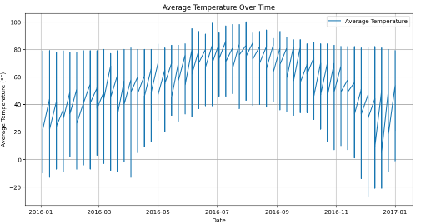

**Step 4:** Visualize the dataset using Bar Plot.

plt.figure(figsize=(12, 6))

plt.bar(data.index, data['Data.Precipitation'], label='Precipitation')

plt.title('Precipitation Over Time')

plt.xlabel('Date')

plt.ylabel('Precipitation (inches)')

plt.legend()

plt.grid(True)

plt.show()

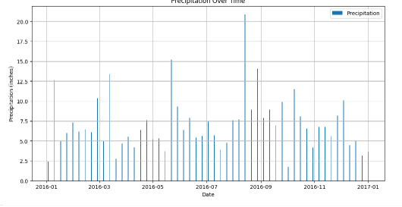

**Step 5:** Visualize the dataset using Heatmap.

plt.figure(figsize=(10, 8))

corr = data[['Data.Temperature.Avg Temp', 'Data.Temperature.Max Temp', 'Data.Temperature.Min Temp', 'Data.Precipitation', 'Data.Wind.Speed']].corr()

sns.heatmap(corr, annot=True, cmap='coolwarm')

plt.title('Correlation Heatmap of Weather Variables')

plt.show()

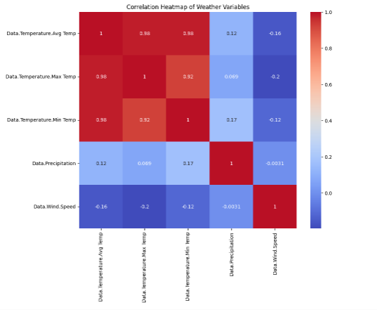

**Step 6:** Visualize the dataset using Boxplot.

data['Month'] = data.index.month

plt.figure(figsize=(12, 6))

sns.boxplot(x='Month', y='Data.Temperature.Avg Temp', data=data)

plt.title('Average Temperature by Month')

plt.xlabel('Month')

plt.ylabel('Average Temperature (°F)')

plt.grid(True)

plt.show()

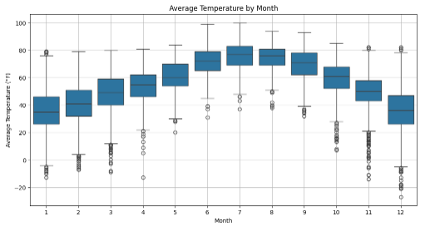

**Step 7:** Visualize the dataset using seasonal decomposition.

decomposition = seasonal_decompose(data['Data.Temperature.Avg Temp'], model='additive', period=12)

plt.figure(figsize=(12, 8))

plt.subplot(411)

plt.plot(decomposition.observed, label='Observed')

plt.legend(loc='upper left')

plt.title('Seasonal Decomposition of Average Temperature')

plt.subplot(412)

plt.plot(decomposition.trend, label='Trend')

plt.legend(loc='upper left')

plt.subplot(413)

plt.plot(decomposition.seasonal, label='Seasonal')

plt.legend(loc='upper left')

plt.subplot(414)

plt.plot(decomposition.resid, label='Residual')

plt.legend(loc='upper left')

plt.tight_layout()

plt.show()

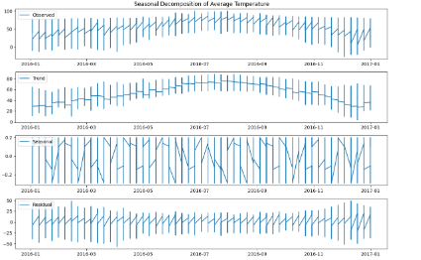

**RESULT:**

Thus the program for visualizing time series weather data completed successfully.